Node JS

Server side javascript program

Node.JS Building Blocks

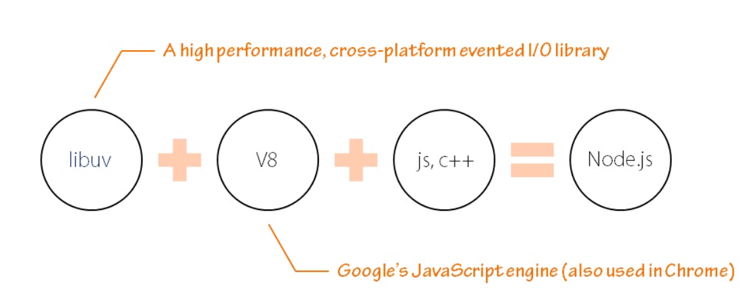

Node Event Loop

From DOM element can trigger an event.

Events from browser, in request and request out and timer event when timer reach

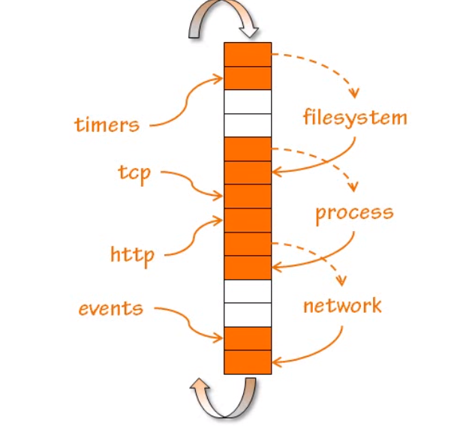

Non Blocking I/O

One request is not blocked others in accessing resources.

First request is executed and second is not blocked and executes.

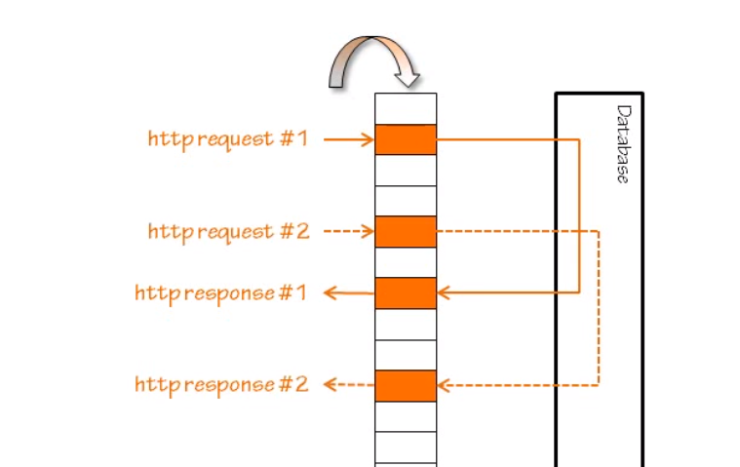

Non blocking is async

One is typical way and another one is non blocking way.

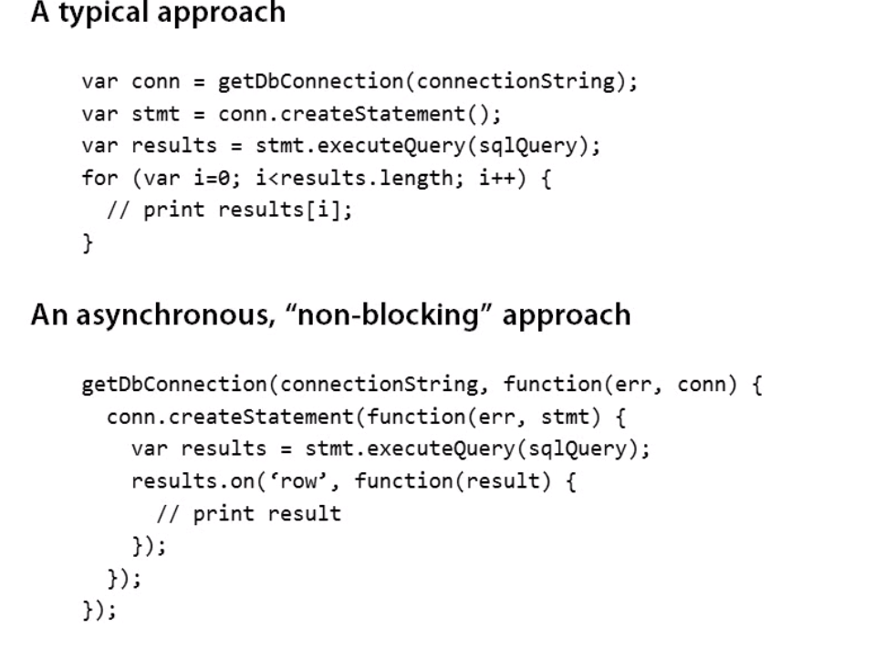

Non blocking way